# ***Congruence Engine*: raising environmental awareness in an interdisciplinary research project**

**Natasha Kitcher, Max Long, Anna-Maria Sichani**

**Overview**

[*Congruence Engine*](http://web.archive.org/web/20241127045938/https://www.sciencemuseumgroup.org.uk/projects/the-congruence-engine) was a digital humanities project which ran between late 2021 and early 2025. Combining the expertise of museum curators, academic historians, and data scientists, the project explored new ways of linking industrial heritage, focussing on three key strands at the heart of UK industrial history: energy, communications, and textiles. *Congruence Engine* was based at the Science Museum in London, and involved the collaboration of more than two dozen partner organisations from across the UK.

We were one of five projects funded by the UK’s Arts and Humanities Research Council (AHRC), as part of its [Towards a National Collection (TaNC)](http://web.archive.org/web/20250104230954/https://www.nationalcollection.org.uk/) funding stream. The TaNC programme explored opportunities for the development of a ‘UK digital collection’ by forging links between heritage items and expanding access to the nation’s collections.

Although UK Research and Innovation (UKRI) and the AHRC have made substantial [infrastructure investments to achieve carbon-neutral computing by 2040](http://web.archive.org/web/20250109092837/https://net-zero-dri.ceda.ac.uk/), the TaNC programme did not develop a shared environmental impact strategy across the projects that it funded. It was not until the final year of the project that we were able to take the time to reflect on our own environmental impact as a project and what that might mean for future recommendations for the development of collections-linking digital infrastructure. We also wanted to explore how the Science Museum Group's own approach to environmental ethics, including their decision to accept corporate sponsorship from major energy corporations such as Adani, might affect our own positionality as individual researchers and as a collective.[1]

**Our approach**

The decentralised and experimental nature of the project, with over 40 investigations taking place simultaneously made it difficult to establish a united approach to environmental ethics. This was also complicated by the interdisciplinary composition of the team, which included museum curators, academic researchers, data and computer scientists, and administrative and managerial staff. The team included individuals employed directly by the Science Museum, as well as collaborators spread across partner institutions. Each team member arrived with a different set of personal priorities and expectations, and technical expertise, as well as being bound by a range of institutional working practices and policies.

Over the course of the project there were sporadic and ongoing discussions about the environmental and social impacts of digital research, and particularly of computationally intensive tasks involving machine learning (ML) and Large Language Models (LLMs). In the last year of the project we established an environmental impact working group, led by Natasha Kitcher, Max Long, Anna-Maria Sichani, and Kunika Kono.

This work was kick-started by Kunika Kono’s decision to investigate her own electricity usage during the project. Kunika used a single board computer to run typical tasks involved in her Congruence Engine work, and recorded the electricity required to perform these tasks using a USB-ammeter (a device for measuring the electrical current in a circuit). The group considered if it would be possible to scale this up for the project as a whole, asking each team member to calculate their usage for a day. The aim of this approach would have been to provide tangible insights into the energy demands of the project’s daily computational activities and to promote greater awareness of the environmental impact associated with their work. But, after investigating a range of hardware and software options, we decided that it would not be feasible to undertake this kind of assessment. We realised that measuring local consumption by a representative sample of the team using an ammeter presented technical challenges, particularly in isolating the consumption associated with individual tasks. Moreover, we were conscious of the fact that some of our largest environmental costs were likely associated with cloud services and other external providers. While numerous tools are available to measure these impacts, their value is principally in awareness-raising, and we found they would not enable us to accurately understand our use of LLMs.

Instead, we focussed our energies on building a collective awareness of the environmental impact of digital research across the project team. Our approach comprised a set of targeted actions:

1. We established a [**Zotero group library**](https://www.zotero.org/groups/5443684/digital_tools_and_the_environment_-_congruence_engine) **on the environmental impacts of computationally intensive research.** This has been mainly used as an initial starting point for our own research and work and gradually developed to a dynamic reference point for the entire project team. The library currently contains 71 resources and is now open to the wider cultural heritage community as a work-in-progress - please feel free to join and add your resources too!
2. We ran a **qualitative survey** to assess our team’s working practices from an environmental point of view, including research and administrative staff.
3. Two members of the team participated in a two-day **Carbon Literacy training** organized by the [Heritage Trust Network](https://heritagetrustnetwork.org.uk/events/) for cultural heritage professionals and researchers.
4. We held a **workshop** for members of the project around environmental ethics in research. This workshop was a great opportunity for us to collectively reflect on the environmental impacts of our research practices, and to share and discuss the results of the survey. Learnings from our Carbon Literacy training course were also shared with the wider team.

**The survey**

The primary goal of our survey was to understand how people within the project thought about the environmental impact they had in their own lives and work. We circulated it to the whole project team, both full-time team members and project partners. Ten people replied in total, mostly individuals with full time roles on the project, with more than half of replies coming from Research Fellows.

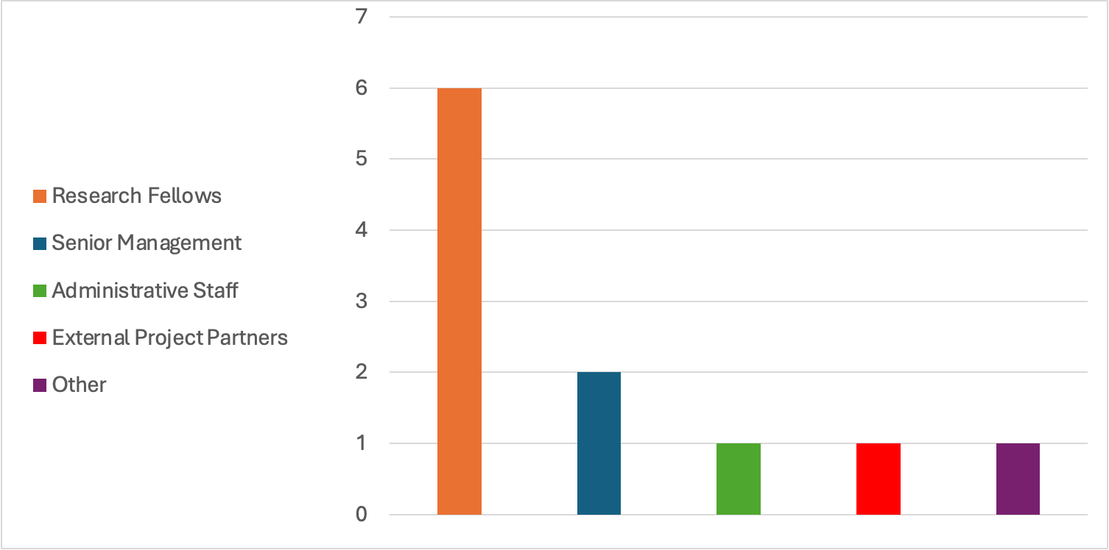

**Figure 1.** Bar chart showing the distribution of responses to the survey based on employment status.

We asked respondents to define ‘environmental impact’, to try and understand their own interpretation of what we were investigating. While many assumed environmental impact was a neutral term, something which could be ‘adverse or beneficial,’ 40% assumed that environmental impact exclusively referred to negative impacts we as humans have on the planet. These answers referred to pollution, deforestation, Co2, and broadly described ‘negative and destabilising effects’. 20% of the team said that they had been involved in environmental work in an official capacity previously, and there was unanimous agreement that reducing the environmental impact of our work was important to them.

Question six in the survey asked if participants had taken actions to reduce their carbon footprint outside of work, with all respondents answering ‘yes’. A follow-up question asked about specific actions of this kind, and the word cloud below shows the most common examples given:

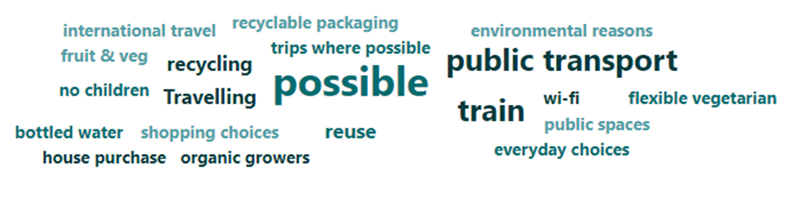**Figure 2.** Word cloud showing the most common words used in response to the question ‘list one or two examples of actions you have taken to reduce your carbon footprint outside of work’. The answers reflect a team that did what they could when possible, often changing their personal travel habits.

Beyond the usual examples of taking public transport, eating less meat, recycling, and avoiding plastic, the word ‘possible’ stood out in particular. Respondents repeatedly stated that they took these actions ‘where possible’, ‘if possible’ and ‘when possible’. In our workshop, which we discuss below, we were keen to dig into this further. The repetition of ‘possible’ spoke to the lack of power felt by many team members when it comes to directly linking small everyday lifestyle changes to shifts in the global climate, even while they remain convinced that these actions are important and worthwhile. The rest of the survey focussed on the team’s working practices. 80% of respondents claimed to have taken some kind of action to reduce their carbon footprint at work, compared to 100% taking action outside work. Responses to the remainder of the questionnaire indicated that many team members felt that they did not have the power to meaningfully reduce their carbon footprint at work. We saw a similar trend when we asked if participants would make different decisions at work if they had a better understanding of the carbon footprint of their job. Half replied with ‘maybe,’ seeming unsure if taking action at work was something they could practically do, or something they needed to work on.

The general sense that reducing their carbon footprint at work was not their job was cemented by responses to question 12: ‘Would you say that your work entails a greater or lower carbon footprint than the average CE team member?’. 60% of team members responded to this question with ‘lower’. This was despite the same percentage of people reporting that they relied on large language models for their work.

We created another word cloud to show responses to the question: ‘Are there any actions relating to environmental impact at work that you feel you are unable to take currently? If so, what are they, and why do you feel unable to take them?’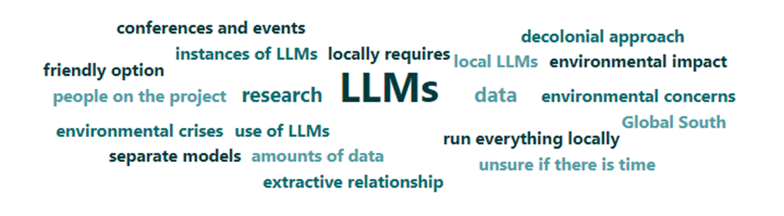 **Figure 3.** Word cloud showing the most common words used in response to the question ‘are there any actions relating to environmental impact at work that you feel you are unable to take currently? If so, what are they, and why do you feel unable to take them?’ The word cloud indicates agreement on LLMs being an issue, but otherwise shows a range of different reasons for feeling unable to take action.

The overwhelming response focused on large language models, indicating a shared belief and experience that with these technologies the power is with the corporations that own the models, and not with the users: suggesting we (as users) are restricted by decisions made without us. There was also a theme of time and efficiency. Researchers sometimes felt obliged to choose certain less environmentally friendly options because they would get tasks done more quickly, because it was the tool the job required and they did not have agency to challenge this decision, or (for those involved in writing software for the project) because they did not have the ability or means to run things locally.

We had the opportunity to discuss these results as a team at a workshop held shortly after the circulation of the survey. It proved a useful exercise to prompt conversations, and enabled us to reflect on the project’s wider attitudes to environmental impact. The survey suggested that, despite a widely-shared desire to understand and reduce the environmental impacts of our working practices, we felt a collective lack of power and agency to implement meaningful change.

**The workshop**

We held a workshop at the Science Museum offices in South Kensington on August 5th, 2024. This workshop served two main purposes:

1. to share the results of our survey with the rest of the team
2. to start a conversation about the team’s use of digital tools in the context of environmental impact

The workshop aligned with the [action research](http://web.archive.org/web/20241128101821/https://journal.sciencemuseum.ac.uk/article/congruence-engine-in-action/#introduction) methodology that was adopted throughout the *Congruence Engine* project, which placed an emphasis on the importance of teamwide reflection as part of the research process. In this section, we will focus principally on the discussion, and what we learned from this process as an interdisciplinary team working in the field of digital cultural heritage research.

At the beginning of the workshop, we asked our colleagues if there were any particular issues that they were keen to raise as part of the discussion. Several suggestions were put forward, ranging from a general expression of interest in the topic to more specific questions about individual tools and the ethical issues surrounding their use from an environmental perspective. Many members of the team were already aware of the environmental impacts of certain tools, either because of their own research interests or due to recent coverage in the news of issues such as the carbon footprint of streaming, or the water consumption required for training and maintaining Large Language Models. However, it was also clear that the circulation of the survey had been a welcome opportunity for many team members to reflect on the environmental consequences of their day-to-day working practices.

The workshop included a presentation which addressed our own positionality as individuals who are either directly employed, or affiliated with, a large institution like the Science Museum Group (SMG). A significant part of this discussion hinged on the recent controversies over the museum’s sponsorship by fossil fuel corporations, particularly in the case of [Adani Green Energy](https://archive.li/sZwxq). Some members of the team expressed deep discomfort towards SMG’s stance on fossil fuel sponsorship, and the [museum’s response](https://archive.li/499wz) to activists who have criticised this stance. We discussed how this context might impact our credibility when speaking on matters relating to environmental ethics, and the similarities and differences of this context as compared to that of researchers working in universities, where the issue of fossil fuel and arms industry investments has also been an ongoing concern.

Overall, the workshop offered a productive space for members of the project to reflect on the environmental impact of their work for the project. There was broad agreement that the combination of the survey and the workshop had encouraged most of us to convert lingering concerns into specific actions. Some examples of these actions included:

* Not sharing large files via email, and avoiding downloading the same file multiple times
* Exploring alternatives to the major LLMs, including smaller models that can be run locally
* Learning and implementing ‘green coding’ practices, including physical hardware as well as reusable software development.

This represented a considerable shift from the survey responses, which had been dominated by a shared feeling of powerlessness when it came to implementing a more sustainable way of working.

**Conclusion**

The *Congruence Engine* team*’*s experiences with raising environmental awareness in a large interdisciplinary research project may offer some lessons for others embarking on similar collaborations in the future. There is a clear need within DH projects to promote open discussion around these issues, and to adopt clear guidelines and policies that prioritise environmental questions when they might otherwise be sidelined. The DHCC Toolkit and the community around it already provide a wide range of helpful resources to this end. At the same time, our experience showed that the specific conditions of working with an interdisciplinary team, with many of us being only temporary employees within large institutions with their own carbon reduction policies and trajectories, presented additional complications when it came to taking environmental action at work.

Our project took place over a period in which the climate stakes of digital research have been raised considerably due to the growing resources being dedicated to training and running LLM chatbots. As with previous moments of growing environmental awareness, the risk is that this can often be accompanied by a paralysing feeling of powerlessness. The survey and workshop that we conducted suggested that investing time in reflective dialogue about everyday working practices is one way to break out of this deadlock.

1. See: <https://www.sciencemuseumgroup.org.uk/our-work/sustainability-approach/>; <https://blog.sciencemuseumgroup.org.uk/setting-out-our-approach-to-the-centurys-defining-challenge/>; <https://blog.sciencemuseumgroup.org.uk/statement-from-dame-mary-archer/>